Project: Serverless Image Processing Pipeline

Overview:
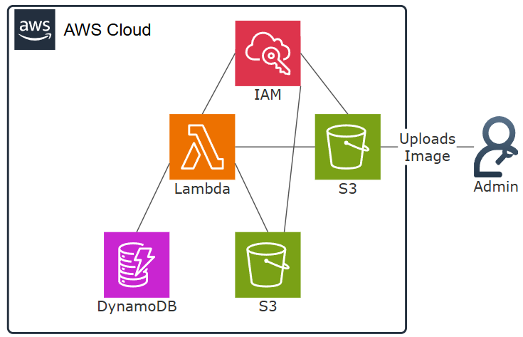
Using Lambda to trigger a function from an upload to an S3 bucket, the function will take the uploaded image and create a 128x128 thumbnail upload that thumbnail to a separate S3 bucket and log the metadata (Filename and Timestamp) into a DynamoDB table.

Skills and Concepts Demonstrated
- Identity and Access Management (IAM): Securely granting permissions to compute resources using IAM Roles.
- S3 Access Control: Implementing the principle of least privilege by restricting S3 access only to the necessary Lambda Role.
- Storage and Compute separation: Separation of unstructured data from S3, the compute layer (Lambda) and the structured data in a DynamoDB table for better maintainability
- Serverless design: Implementing an event driven architecture that eliminates idle server costs by using Lambda and event triggers (S3 event notifications)

Architecture Overview (The Plan)
- S3 Bucket: The two buckets created will 1. Host the uploaded files triggering the lambda function and 2. Host the processed images.
- IAM Role: This is the secure way to grant the Lambda function access to both the S3 buckets and the DynamoDB table.
- Lambda Layer: I’ll be using the Pillow library for python 3.14 which is not by default included within Lambda, so I’ll need to create a Lambda Layer and assign it to the function.
- DynamoDB: Create a DynamoDB table to host the Filename (partition key) and Timestamp (sort key) of the processed images.
- Lambda Function: This is where I’ll write my code to handle the image processing, the uploading of the edited image to the 2nd S3 bucket and the upload of the metadata to the DynamoDB.

Section 1: Creation of the S3 Buckets, DynamoDB table and Lambda function

1. Creating the two S3 buckets
First, I need to create a role that my EC2 instance can assume at launch. This is how I securely grant access to my S3 bucket.
Firstly, I’ll need to create two S3 buckets that will host my user uploaded images and the processed images. Then later well assign the necessary permissions to allow our Lambda function to access the buckets.
Steps:
- Navigate to the S3 Console and select Create bucket.
- Name the bucket I’ve gone with image-pipe-line-orig and image-pipe-line-resized for the two buckets.
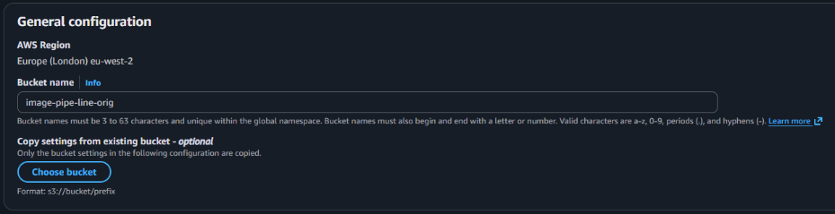
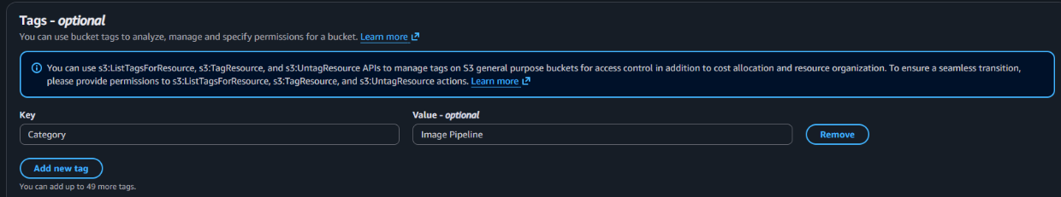
- Scroll to the bottom of the page and click the “Add new tag” button and assign any tags I’ve gone with Category > Image Pipeline for both the buckets.

2. Creating the DynamoDB Table
This Table will be where we hold all of our metadata the Filename and the Timestamp of the operation.
Steps:
- Navigate to the DynamoDB console and click on the “Create table” button
- Name the new table, I’ve gone with ImagePipeline as mine.
- Add our Partition Key and our Sort Key. I’ve used FileName and TimeStamp
- Leaving the table settings at default is the fastest way to create the table, we wont need to change anything here, most of the settings are adjustable after table creation anyway.
- Like with the S3 bucket well add a tag to the table to help with organisation, I again have gone with Category > Image Pipeline
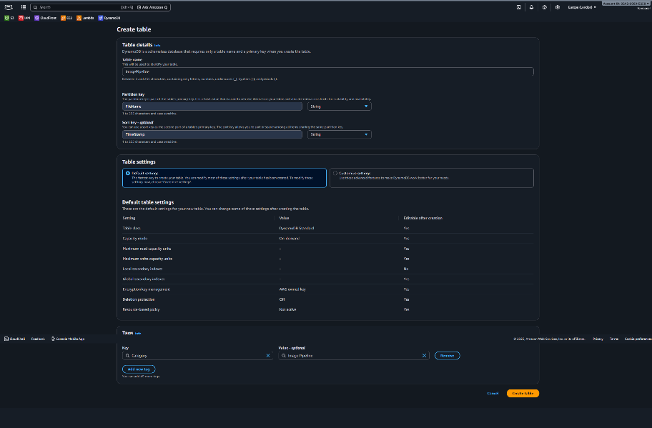
- Click the “Create Table” button at the bottom.

3. Creating the Lambda function.
The Lambda function will be where the Python code will run to process the image and store the metadata into our DynamoDB
Steps:
- Navigate to the Lambda console and click “Create function”
- Make sure that “Author from scratch” is selected
- Name the function, I’ve gone with Resize
- Select the runtime, this is the language used to write the function, for this example I’m using Python 3.14
- For the architecture I’m using x86_64
- Expand the “Change default execution role” section and make a note of the role name that Lambda will create, later we will edit the permissions of the role to allow access to both S3 buckets as well as the DynamoDB table
- Under additional configurations there will be the option to add a tag to the function and again, I’ve gone with Category > Image Pipeline
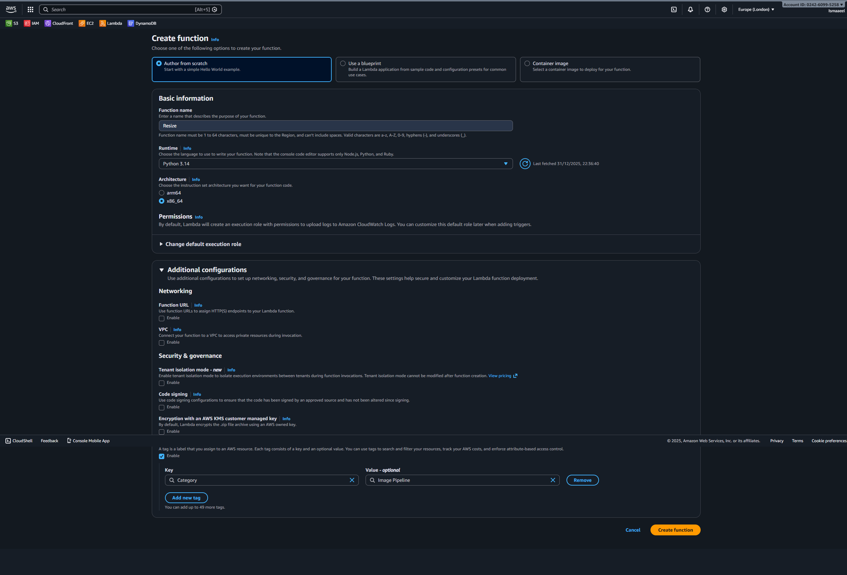

Section 2: Permissions
  - Setting permissions for the two S3 buckets
Both the buckets will need the proper policy adjustments to allow our Lambda function(The IAM role accossiated with the function) to ListBucket, GetBucketLocation, PutObject and GetObject
Steps:
- Navigate back to the first S3 bucket that was created
- Click on the Permissions tab
- Click edit on the “Bucket Policy” section
- Adjust the policy to allow the S3 actions mentioned above and set the principle to the ARN of the role that Lambda created.
- The “Resource” section needs to allow access to the bucket and to the objects inside.
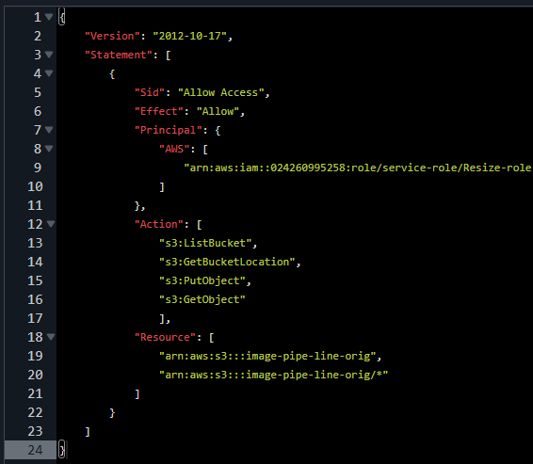
- Do this for both the buckets only thing that needs to change is the “Resource” section, just adjust the bucket name.

2. Setting permissions for the IAM role created by Lambda
The Lambda created IAM role will need permissions to before being able to do anything with our S3 buckets, the objects within them and the DynamoDB table.
Steps:
- Navigate to the IAM console and select the Roles section
- Select the Lambda created role we made a note of before
- By default, there will be a single Policy named “AWSLambdaBasic…” already attached we can ignore that, instead click on the “Add permissions” button
- Select “Create inline policy” and change the tab to the “JSON” view
- Add the same permission added to the S3 buckets 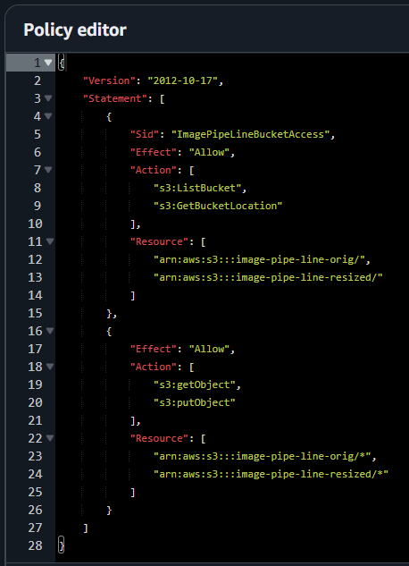
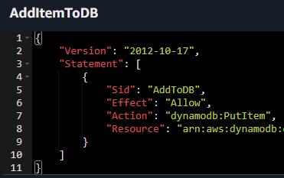
- Create a new inline policy, this time we will allow the function to access the DynamoDB (PutItem)

Section 3: Lambda and verification

3. Adding Pillow as a Lambda Layer
In order to use Pillow (Image processing lib for Python) we will need to package it and upload it as a Lambda Layer as its not included by default. Python will need to be installed on the machine, pip install will be used to create the Pillow package, I use Windows 11 so the packaging section will be done from within Command Prompt (CMD)
Steps:
- Navigate to your Desktop (Or anywhere you want to create this package)
- Create a Folder named Pillow_Layer
- Create a subfolder named python (case sensitive) and open it
- Open CMD and navigate to the python subfolder
- Run the following command within CMD:
pip install ^
--platform manylinux2014_x86_64 ^
--target python/ ^
--implementation cp ^
--python-version 3.14 ^
--only-binary=:all: Pillow
- Once the Pillow package has been downloaded and stored within the python subfolder, we will need to create a zip file, right click the python subfolder and select “Compress to…” > “ZIP File”
- Rename the zip file, I’ve gone with Pillow_Layer
- Navigate to the Lambda Console
- Select “Layers” on the left
- Click “Create layer”
- Give the new layer a name and a description
- Upload the ZIP file created earlier
- Click Create
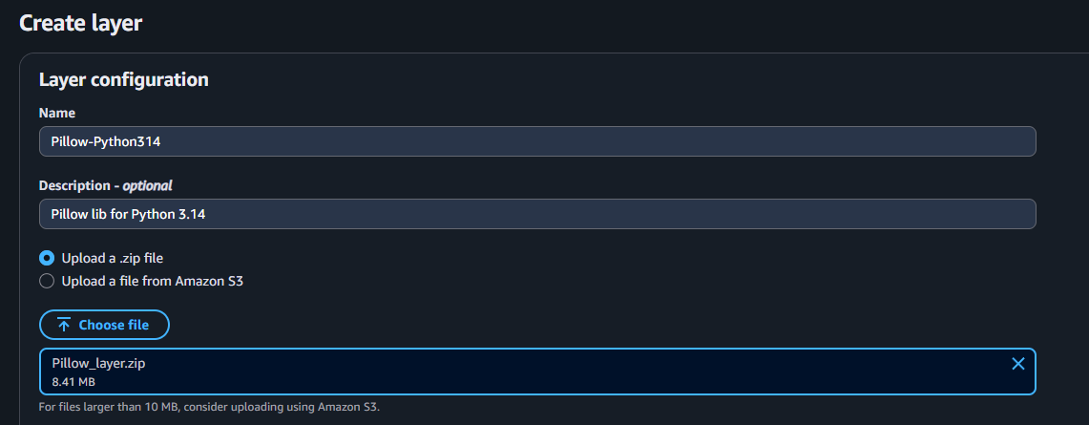

4. Editing the Lambda function
Now comes the writing of the Lambda function, everything is in place for the function to be written, the S3 buckets, DynamoDB table, The various permissions and now finally the Pillow layer
Steps:
- Navigate back to the Lambda console
- Select the functions section
- Navigate to the function created earlier
- Under “Function overview” click “Add trigger”
- Select S3 as the trigger
- The bucket will be the host bucket (pre-processing)
- Under event types I’ve deselected “All object create events” and only selected the “PUT” option
- Acknowledge the “Recursive invocation” checkbox
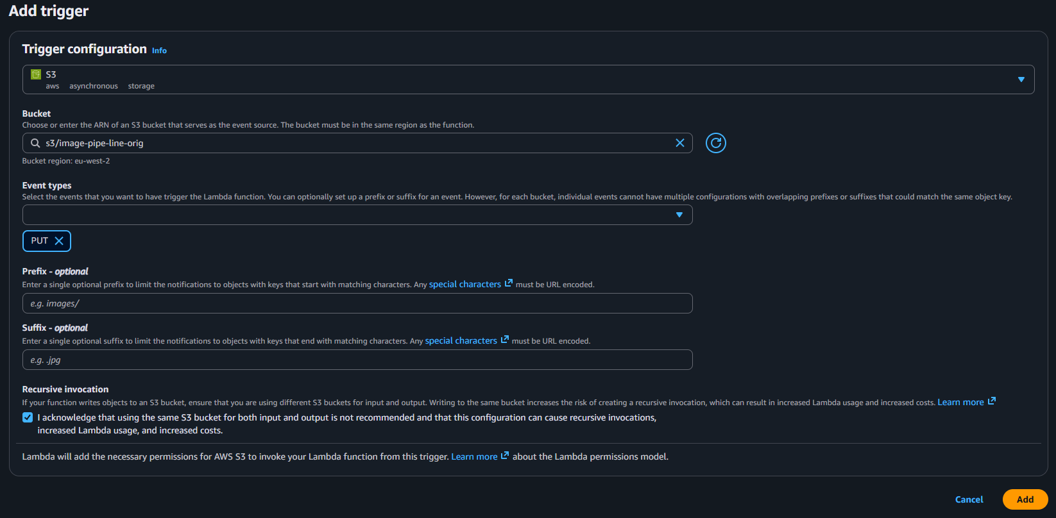
- Click “Add”
- Scroll to the bottom of the page and select “Add layer”
- Select either “Custom layers” or “Specify an ARN” and select the layer created earlier (or enter the layer ARN)
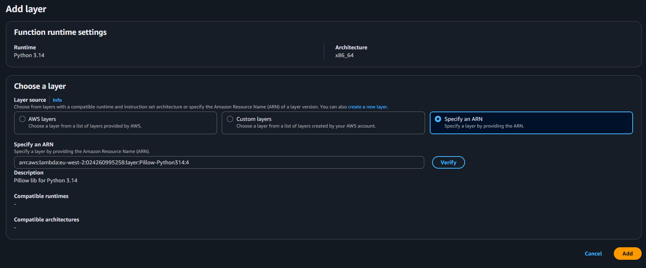
- Click “Add”
- Now time to actually write the function, I won’t go into detail here about how to use boto3 or how to write a python function but I’ll have the code available at the bottom of this document

7. Verification and code
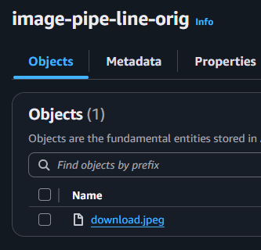
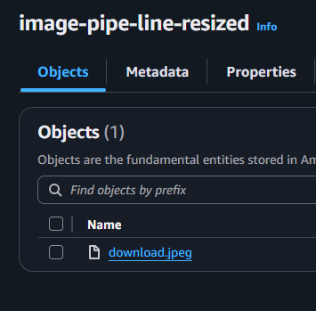
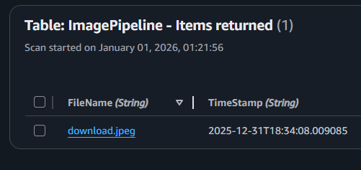
Once everything is done test the project by uploading an image to the host bucket and either check the CloudWatch for any errors but its more fun to check the other bucket and the DynamoDB table.

Purpose | Code
S3 Bucket Policies (Top one is for the host bucket, the bottom is for the resized bucket) | {  "Version": "2012-10-17",  "Statement": [  {  "Sid": "Allow Access",  "Effect": "Allow",  "Principal": {  "AWS": [  "ARN"  ]  },  "Action": [  "s3:ListBucket",  "s3:GetBucketLocation",  "s3:PutObject",  "s3:GetObject"  ],  "Resource": [  "arn:aws:s3:::image-pipe-line-orig",  "arn:aws:s3:::image-pipe-line-orig/*"  ]  }  ]  }  {  "Version": "2012-10-17",  "Statement": [  {  "Sid": "Allow Access",  "Effect": "Allow",  "Principal": {  "AWS": [  "ARN”  ]  },  "Action": "s3:*",  "Resource": [  "arn:aws:s3:::image-pipe-line-resized",  "arn:aws:s3:::image-pipe-line-resized/*"  ]  }  ]  }
Lambda Bucket access | {  "Version": "2012-10-17",  "Statement": [  {  "Sid": "ImagePipeLineBucketAccess",  "Effect": "Allow",  "Action": [  "s3:ListBucket",  "s3:GetBucketLocation"  ],  "Resource": [  "arn:aws:s3:::image-pipe-line-orig/",  "arn:aws:s3:::image-pipe-line-resized/"  ]  },  {  "Effect": "Allow",  "Action": [  "s3:getObject",  "s3:putObject"  ],  "Resource": [  "arn:aws:s3:::image-pipe-line-orig/*",  "arn:aws:s3:::image-pipe-line-resized/*"  ]  }  ]  }
Lambda DynamoDB access | {  "Version": "2012-10-17",  "Statement": [  {  "Sid": "AddToDB",  "Effect": "Allow",  "Action": "dynamodb:PutItem",  "Resource": "ARN"  }  ]  }
Lambda Python Code | import json  import boto3  import urllib.parse  import io  import datetime  from PIL import Image  s3=boto3.client("s3")  db=boto3.client("dynamodb")  def lambda_handler(event, context):  timestamp=datetime.datetime.now().isoformat() #gets the timestamp to be uploaded into dynamodb  uploadBucket='image-pipe-line-resized' #this is the bucket to place the resized images  bucket=event['Records'][0]['s3']['bucket']['name'] #this gets the name of the bucket that triggered the function  raw_key=event['Records'][0]['s3']['object']['key'] #this gets the name of the file that was uploaded to the bucket  key=urllib.parse.unquote_plus(raw_key) #reformats the filename to remove url encoding  file_name=key.split('/')[-1] #removes any "/" in the name  #essentially turns "bucket/download%1" into "download 1"  #the file by default is a dictornary/network stream, read the stream and transfer the data into the functions RAM as bytes to be read  raw_image=s3.get_object(Bucket=bucket, Key=key)  content_image = raw_image['Body'].read()  #take the image and load it into memory as an object to be processed, process the image and again load it into RAM to be uploaded into a new S3 bucket  image=Image.open(io.BytesIO(content_image))  image.thumbnail((128,128))  proc_image= io.BytesIO()  image.save(proc_image, format='JPEG')  proc_image.seek(0)  #uploads the image into a different bucket  s3.put_object(  Bucket=uploadBucket,  Key=key,  Body=proc_image  )  #this will add our filename as well as the timestamp to our dynamodb  db.put_item(  TableName='ImagePipeline',  Item={  'FileName':{'S': file_name},  'TimeStamp':{'S': timestamp}  }  )  return{  'statusCode': 200,  'body': json.dumps({  'message':'Success',  'bucket':bucket,  'key':raw_key,  'file_name':file_name  })}

